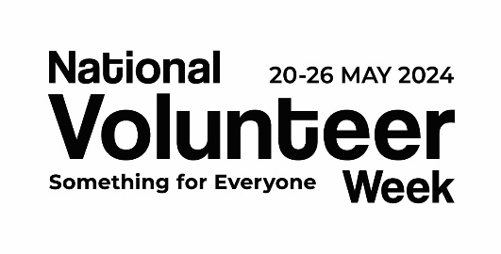
TATIARA DISTRICT COUNCIL
VOLUNTEER OF THE YEAR AWARD 2024
NOMINATION FORM

This completed form should be returned via email to office@tatiara.sa.gov.au, posted to Tatiara District Council, PO Box 346, Bordertown SA 5268 or dropped into our Bordertown or Keith office. It must be received by 5pm, 6 May 2024.
NOMINATOR

Name
Your Volunteer Organisation
Your email
Your telephone
What is your relationship with the nominee(s)?
NOMINEE(S)
Name of individual
Address
Best contact number
Age of individual (if under 18)
Which organisation do they volunteer for?
NOMINATION
In no more than 300 words, briefly describe the voluntary activity carried out by the individual(s). Please explain how this has had a positive impact on your organisation and tell us how they have gone the extra mile to make a difference in the Tatiara. We want to know why their name(s) deserve to be in lights!

Tatiara District Council will be acknowledging the successful winner of the Volunteer of the Year award during National Volunteer Week.

NOMINEE(S)
300 word nomination

